

QUALITY MANAGEMENT PLAN

**Version1.1**

**Quang Vuong**

**04/11/2019**

**VERSION HISTORY**

|  |  |  |  |  |  |
| --- | --- | --- | --- | --- | --- |
| **Version #** | **Implemented**  **By** | **Revision**  **Date** | **Approved**  **By** | **Approval**  **Date** | **Reason** |
| 1.0 | Quang Vuong | 4/11/2019 |  |  |  |
| 1.1 | Quang Vuong | 09/11/2019 | Team | 09/11/2019 | Team review and update |
|  |  |  |  |  |  |
|  |  |  |  |  |  |

Contents

1. Introduction 3

2. Scope 4

3. Role and Responsibility 4

4. Quality Assurance Activities 4

4.1. Manage Schedule 4

4.2. Methodologies 4

4.3. Risk Management 5

4.4. Tools 5

## Introduction

This document includes all the activities of the performing project team that determine methodologi, objectives and responsibilities so that the project will satisfy the needs for which it was undertaken.

The Quality Management Plan include:

* Scope
* Role and responsibility
* Manage schedule
* QA
* Risk management
* Tools

## Scope

The Quality Management just release process and how management schdule, quality assurance...

## Role and Responsibility

|  |  |  |  |
| --- | --- | --- | --- |
| No | Name | Role | Responsibility |
| 1 | Project manager | QA | Delivery plan, metric, process & criteria. |
| 2 | Customer | QC | Validate phase requirement & phase design |
| 3 | Develop team | Develop project | Develop project |
| 4 | Mentor | QC | Verify project, validate phase test |

## Quality Assurance Activities

### **Methodologies**

#### **Planning**

#### **Process**

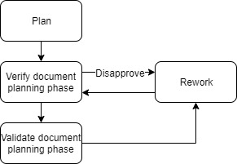

#### **Description planning process**

|  |  |  |  |  |
| --- | --- | --- | --- | --- |
| **Input** | **Activities** | **Role** | **Output** | **Description activities** |
| Project planning | Plan | Project manager | Measurement & metric | Delivery plan, purpose ensure quality at the document planning phase include metric and criteria |
| Communication Plan, Configuration Plan, Project Charter, Project Plan, Development Process, Quality Management Plan, Measurement Plan, Risk Management Plan, Requirement Plan, Requirement Process  Architecture Plan and Process, Architecture Plan, Architecture Process  Details Design Plan and Process, Details Design Process  Implementation Plan and Process, Implementation Plan, Implementation Process  Test Plan and Process, Test Plan, Test Process Training Plan, Training Plan | Verify document planning phase | Project manager, Develop team | Communication Plan, Configuration Plan, Project Charter, Project Plan, Development Process, Quality Management Plan, Measurement Plan, Risk Management Plan, Requirement Plan, Requirement Process  Architecture Plan and Process, Architecture Plan, Architecture Process  Details Design Plan and Process, Details Design Process  Implementation Plan and Process, Implementation Plan, Implementation Process  Test Plan and Process, Test Plan, Test Process Training Plan, Training Plan were verified | Project manager & develop team verify all of file |
| Communication Plan, Configuration Plan, Project Charter, Project Plan, Development Process, Quality Management Plan, Measurement Plan, Risk Management Plan, Requirement Plan, Requirement Process  Architecture Plan and Process, Architecture Plan, Architecture Process  Details Design Plan and Process, Details Design Process  Implementation Plan and Process, Implementation Plan, Implementation Process  Test Plan and Process, Test Plan, Test Process Training Plan, Training Plan were verified | Validate document planning phase | Mentor | Communication Plan, Configuration Plan, Project Charter, Project Plan, Development Process, Quality Management Plan, Measurement Plan, Risk Management Plan, Requirement Plan, Requirement Process  Architecture Plan and Process, Architecture Plan, Architecture Process  Details Design Plan and Process, Details Design Process  Implementation Plan and Process, Implementation Plan, Implementation Process  Test Plan and Process, Test Plan, Test Process Training Plan, Training Plan were validated | Mentor validate all of file |

#### **Requirement**

#### **Process**

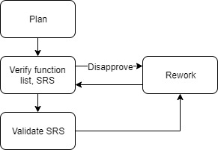

#### **Description quality requirement process**

|  |  |  |  |  |
| --- | --- | --- | --- | --- |
| **Input** | **Activities** | **Role** | **Output** | **Description activities** |
| SRS, function list | Plan | QA | Measurement & metric | Delivery plan, purpose ensure quality at the requirement phase include metric and criteria |
| Function list, SRS | Verify function list, SRS | Mentor, develop team | Function list, SRS were verified | Mentor &develop team will verify function list, SRS |
| Function list, SRS | Rework | Develop team | Document reworked | The group will rework the defective document |
| Function list, SRS were verified | Validate SRS | Customer | Validated SRS document | Customer will validate the SRS document |



#### **Design**

#### **Process**

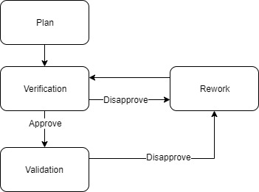

**4.2.2.2. Description quality design project**

|  |  |  |  |  |
| --- | --- | --- | --- | --- |
| **Input** | **Activities** | **Role** | **Output** | **Description activities** |
| Architecture drivers document, Software architecture document, software design specification. | Plan | QA | Measurement & metric | Delivery plan, purpose ensure quality at the design phase include metric and criteria |
| Architecture drivers document, Software architecture document, software design specification. | Verification | Mentor | Architecture drivers document, Software architecture document and software design specification were verified | Mentor will verify all of file for phase design |
| Incorrect document | Rework | Develop team | Document reworked | The group will rework the defective document |
| Software design specification. | Validation | Customer | Validated software design specification. | Customer will validate the document |
| Architecture drivers document, Software architecture document and software design specification were verified | Validation | Mentor | Validated architecture drivers document and software architecture document | Mentor will validate the document architecture |

#### **Code & Test**

### **Process**

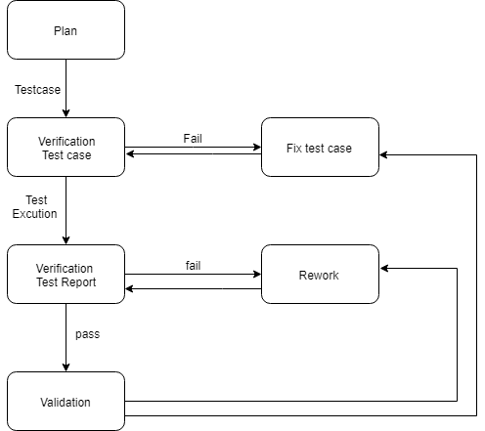

### **Test review process description**

|  |  |  |  |  |
| --- | --- | --- | --- | --- |
| **Input** | **Activities** | **Role** | **Description** | **Output** |
| Test case, test report | Plan | Mentor | Measurement & metric | Test plan, test case |
| Test case document | Verification Test case | QC | Check whether the test case design is fully implemented or not | Test case |
| Test report, Code | Verification test Report | QC | Check whether the test case execution is complete or not | Test report |
| Test case document | Fix test case | Tester, QC | Update test case | Test case |
| Test report, code | Rework | Develop Team, Test team | Repeated implementation of test cases | Test Report |
| Test case, Test report, Defect List | Validation | Mentor | The mentor checks the end product evaluation process to check if the software meets the business requirements? | Test Report |

### **Risk Management**



**PM_RiskManagementPlan_Ver1.0.docx**

### **Tools**

* Excel